Introduction to ATR technique (Attenuated Total Reflectance)

While traditional IR spectrometers have been used to analyze solids, liquids and gases by means of transmitting the infrared beam directly through the sample, ATR uses the reflectance of the sample instead. An attenuated total reflection measures the change that occurs in a totally internally reflected infrared beam when the beam comes in contact with the sample. The infrared beam hits an optically dense crystal (i.e. diamond, zinc selenide or germanium) which then creates an evanescent wave that subsequently protrudes the sample (0.5-5 μm). The regions where sample absorbs energy, the evanescent wave will be altered, which will be detected.

It is important that the sample has good contact with the ATR crystal because the small extension of the evanescent wave beyond the crystal. This is accomplished by applying a moderate pressure to the sample during the measurement. Full and intimate contact of the sample onto the ATR crystal is essential to achieve high quality results. T he refractive index of the crystal has to be significantly greater than the one of the sample.

Sample
ATR

Incident
Attenuated IR beam to detector
IR beam

While the analysis of samples by ATR is widely used, there are several factors that affect the quality of the final spectrum such as the refractive indices of the ATR crystal and the sample (n crystal > n sample), angle of incident IR beam, depth of penetration, wavelength of the IR beam, number of reflections, quality of the sample contact with ATR crystal, etc. The critical angle is given by

For instance, a diamond/ZnSe system possesses a refractive index of n crystal =2.4 and a critical angle of θc=38.7o. If the refractive index of the sample is higher than the refractive index of the crystal, derivative shaped absorbance bands are observed (see below) since the critical angle requirement was not met. The resulting spectrum is a mix of the ATR and external reflectance. The penetration depth is directly proportional to the wavelength of the incident beam, which means that photons with higher wavenumbers penetrate the sample less than photons with lower wavenumbers. Consequently, peaks on the left hand side often appear a little smaller than expected i.e. OH peaks, etc. It is important to correct this effect by applying the ATR correction to the raw spectrum.

General Pointers:

- The FTIR instrument is located in MIC 109. Login is with Yale Net ID and password. You should create a folder with your name inside the data folder for your samples. It is equipped with an ATR with Diamond crystal.

- The ATR has to be cleaned after each measurement. Keep in mind the film left over is often more reflective than the samples applied due to better contact, which can lead to false spectra. If unsure about the quality of the cleaning, a new background spectrum should be acquired prior to applying the sample to the crystal.

- The setup should be cleaned using KIMWIPE moistened with iso-propyl alcohol. Please do not squirt the alcohol directly on the plate.

- The applied pressure has to be adjusted to the quantity and nature of the sample: the thicker the sample is the higher pressure should be in order to have better reflectance. Generally 20 mg of solid or 50 ul of liquid sample are sufficient. The high pressure clamp should be turned to its slip-clutch limit to achieve maximum pressure (2 clicks). The pressure has to be released in order to be able to remove the clamp. If this is not done, the pin will hit the germanium crystal the next time it is placed on the sample and break it.

- The Agilent Cary 600 Series FTIR spectrometers use a helium-neon laser operating in the visible region at 632.8 nanometers. The spectrometer is a Class 2 laser product, powerful enough to warrant caution in its use.

Cleaning the ATR module

i. Scratching the crystal surface must be avoided at all cost!! It is expected some residual sample will be left.
ii. Much of the formed pellet can be dislodged with a wooden stick. A metal spatula will be potentially too abrasive and damaging to the crystal.
iii. With the remaining solid at the edges, apply some isopropanol, dab the top with a kimwipe, and repeat this 4-5 times.
iv. Also use this to scrub the general area in and around the crystal surface. It is not necessary to do this for more than a second or two. The solvent should not be applied in a way that the setup is soaked since it will leak into the optics as well.
v. Remember to wipe the surface of the screw above.
vi. The next background scan will subtract any remaining residue.

Operating the Agilent Cary 660 FTIR

- Login to the computer with your Yale ID & Password.
- Launch the Agilent Resolution Pro Software: 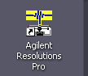
- Click on Collect Method Editor:

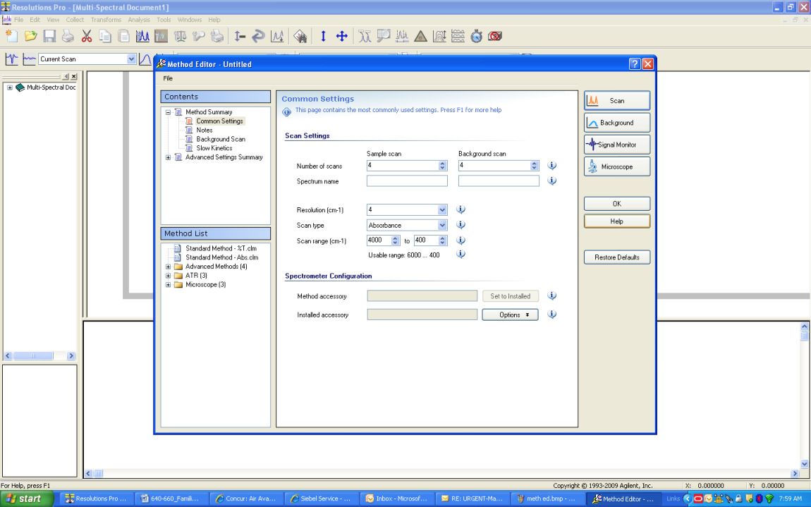
Methods have been created using a standard Mid-IR configuration , KBr beamsplitter, Mid-IR source and DTGS detector .

- Choose Method: Main Bench ATR from column on the left.
- Click on Signal monitor button.

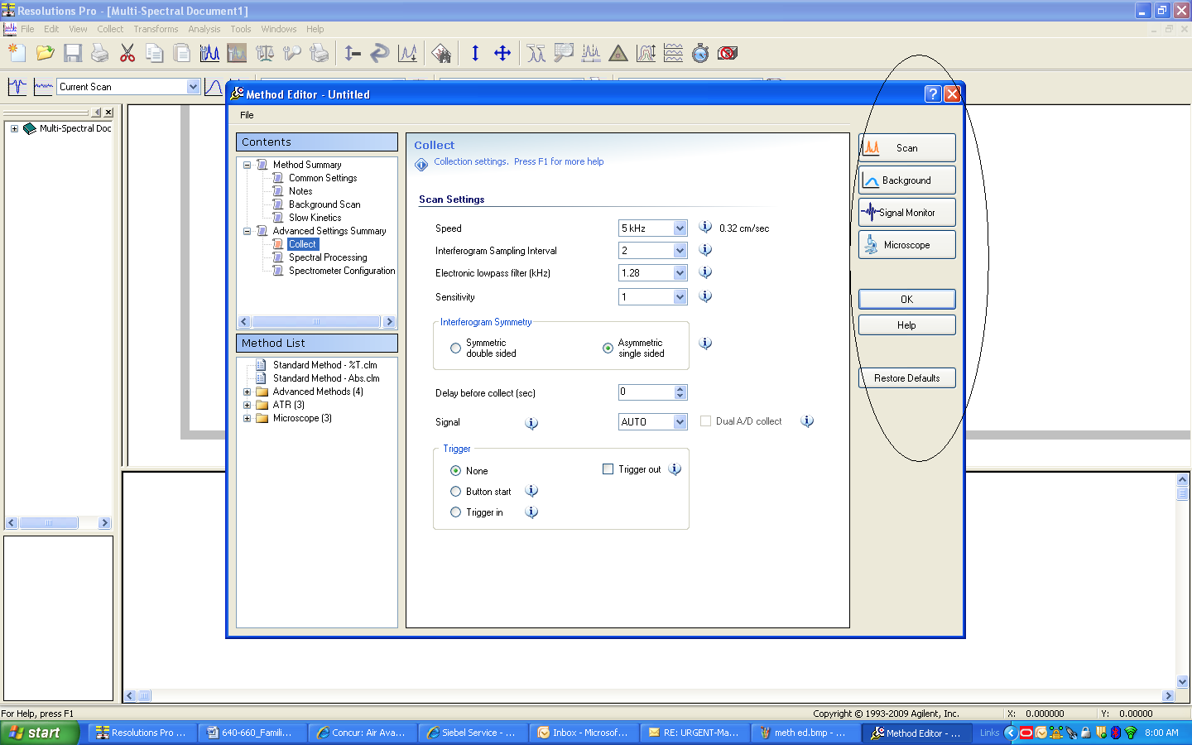

- Check the voltage displayed above the centerburst EVERYTIME, and confirm that the voltage reads above 6.01, keep log.

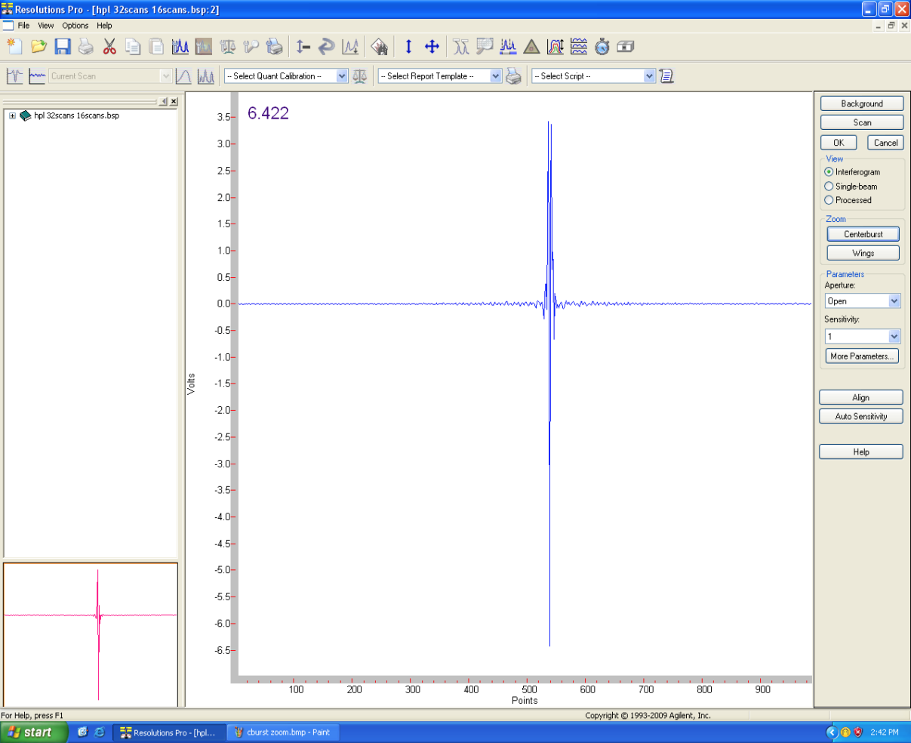

To run your method (liquid sample):
- Choose Method: Liquid ATR Ge from left column.
- Run Background.
- Place a drop (5 0μl) of sample on the crystal.
- Run Scan
- The spectrum obtained is Scan –Background.
- Save the spectra in your folder.
The arm does not need to be lowered for the background or liquid sample.

To run your method (solid sample):
- Choose Method: Main Bench ATR from left column.
- Run Background.
- Place the powder sample, and lower the arm to ensure good contact.*
- Run Scan
- The spectrum obtained is Scan –Background.
- Save the spectra in your folder.
*Alternately, dissolve the solid sample in a volatile solvent, place a drop onto the crystal and let evaporate. Do not lower arm.

To finish:

Clean the crystal with KIMWIPE moistened with iso-propyl alcohol. Let air dry. Logout.

